**Change Directory permission in Linux:**

changing directory permissions in Linux is done using the **CHMOD** command, which modifies the permissions of files and directories

**Understanding Linux Permissions**

Before changing permissions, it’s important to understand how permissions are structured in Linux. There are three types of permissions:

* **Read (r):** Allows viewing the contents of a directory.
* **Write (w):** Allows modifying the contents of a directory (e.g., creating, deleting files).
* **Execute (x):** Allows entering the directory (i.e., cd into it).

Permissions are assigned to three categories:

* **User (u):** The owner of the file or directory.
* **Group (g):** Users who are members of the file’s group.
* **Others (o):** All other users.

**Step 1: Create a Directory**

Here I create a directory name ‘Pratik’ by mkdir command.

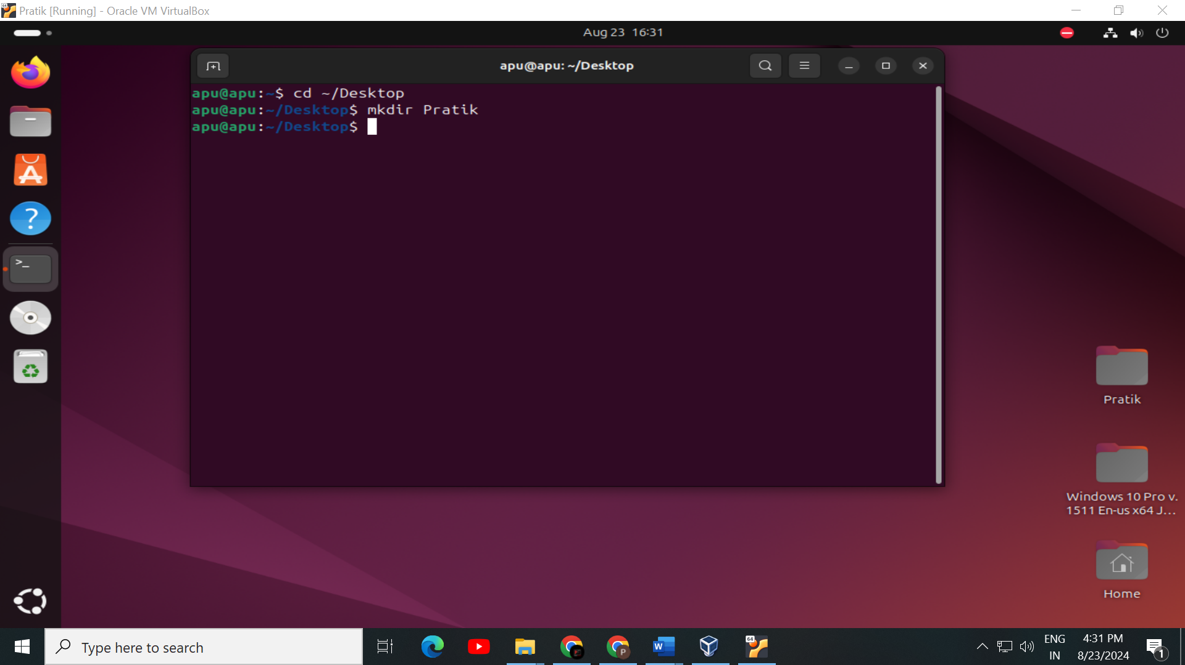

**Step 2: Check the permission of the directory ‘Pratik’**

Here check directory permission by **‘ls -l’** command.

Here, ‘**drwxrwxr-x’** indicates the permissions of the directory **Pratik**

here d means directory,

First three alphabet represent the read write and execute permission of the ‘owner’ of the directory second three alphabet is representing the permission for the ‘group’ of the directory, last three alphabet is representing the permission for ‘other users’ of the directory

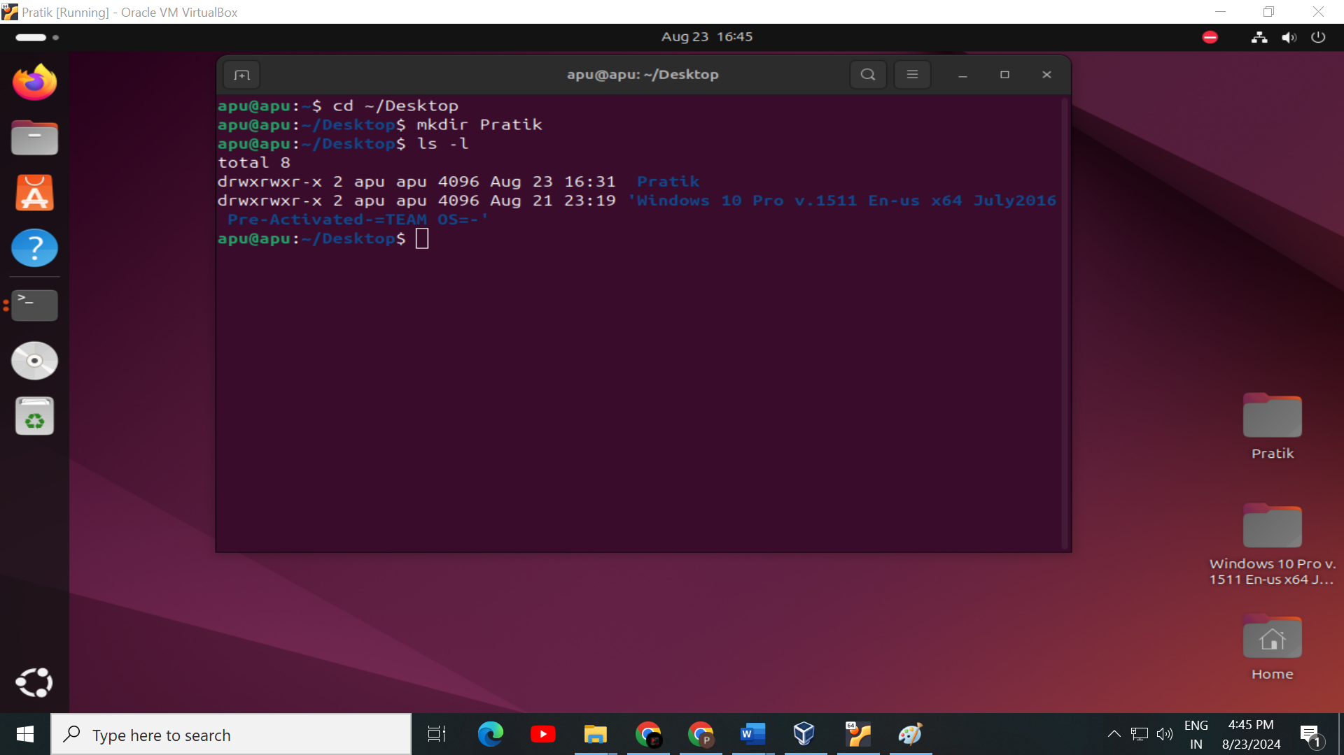

**Step 3: Change the permission of the directory ‘Pratik’**

The **CHMOD** command is used to change the permission of any directory.

#### **1. Symbolic Mode**

In symbolic mode, you use symbols to change permissions:

* u for user, g for group, o for others, and a for all.
* + to add a permission, - to remove a permission, and = to set an exact permission.

#### **2. Numeric Mode**

In numeric mode, you represent permissions with numbers:

* r = 4, w = 2, x = 1
* Add the numbers to get the desired permissions.

I use numeric mode to change permission. I give the only read and write permission to the (**User)** The owner of the file ,gave only write permission to the **Group (g) and Read** and **Execute** permission to other users **(o).**

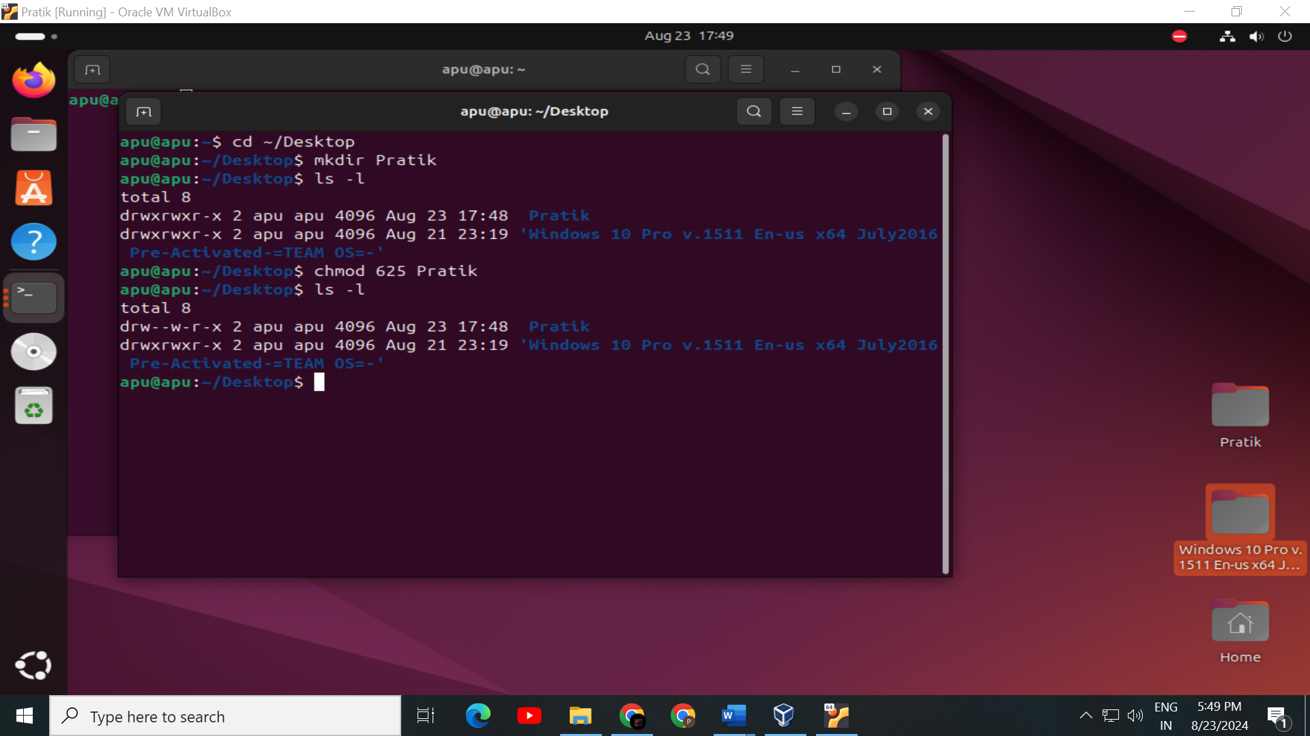

**Step 4: Check the result of the directory ‘Pratik’ for permission changes**

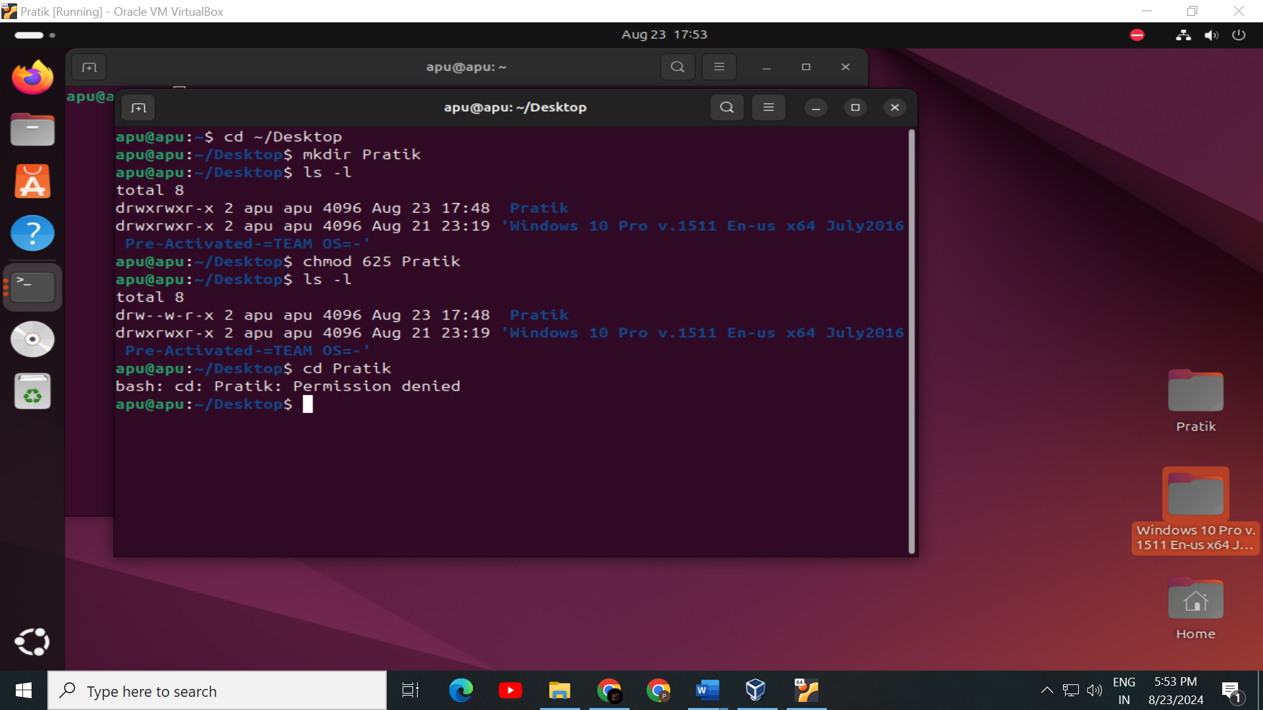

We cannot enter the directory ‘**Pratik’** because the owner don’t have the execute permission.

By following these steps, you can effectively manage and change directory permissions in Linux, ensuring proper access control for your files and directories.